**Lab Sheet 01**

1.

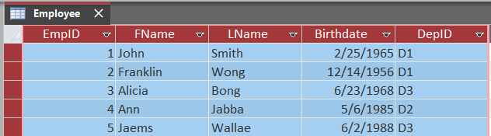

Foreign Key=DepID

2.

**Lab Sheet 03**

**Scenario: 1**

**Lab Sheet 04**

**Scenario 1:**

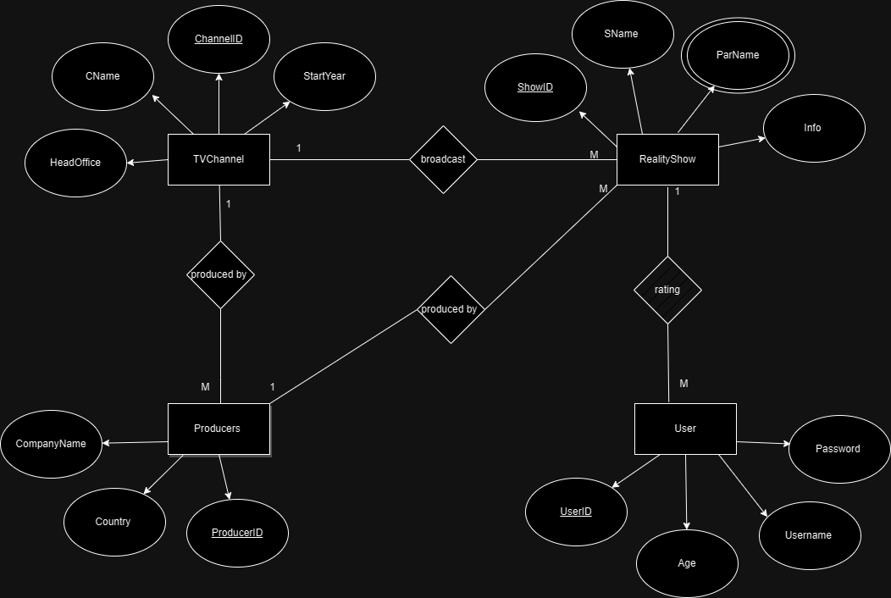

**Scenario 2:**

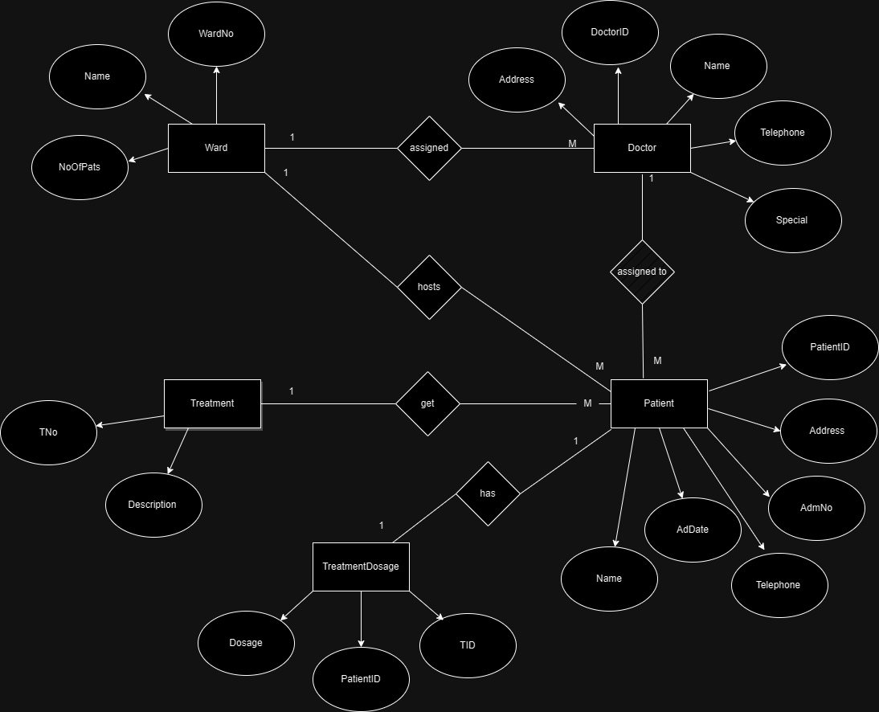

**Lab Sheet 05**

**Question 01**

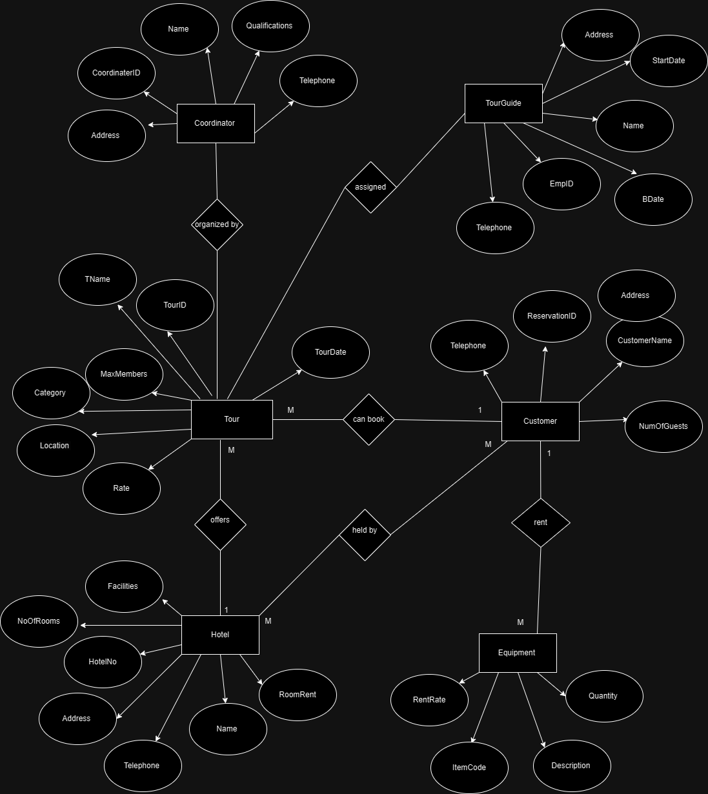

**Question 02**

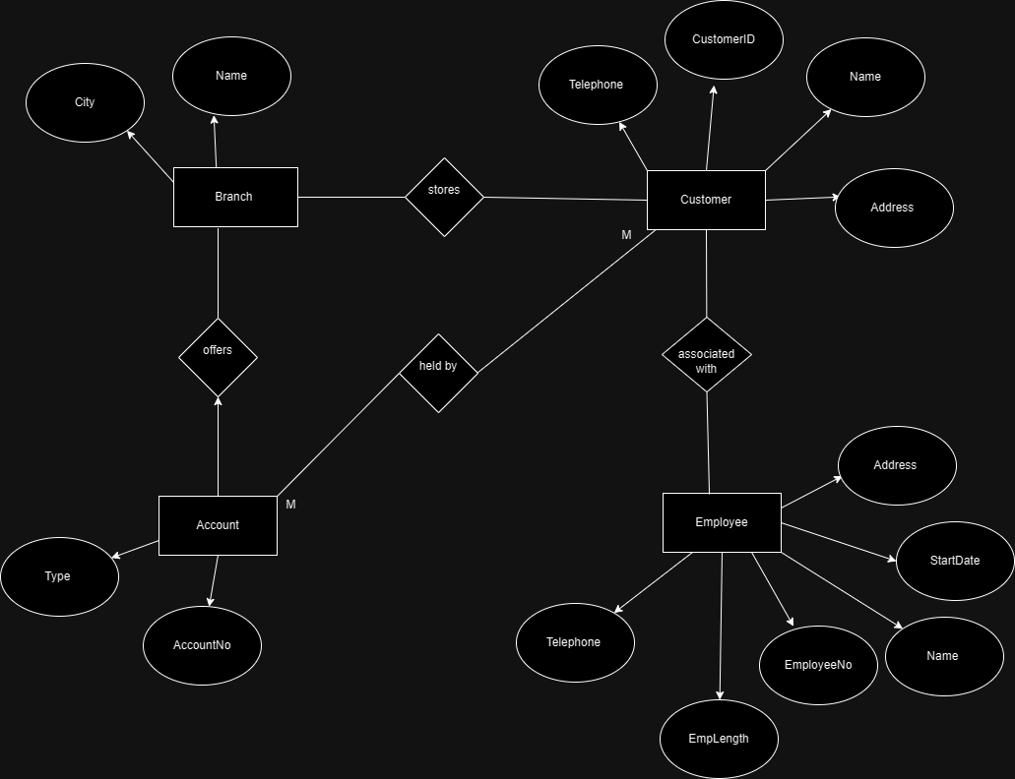

**Lab Sheet 06**

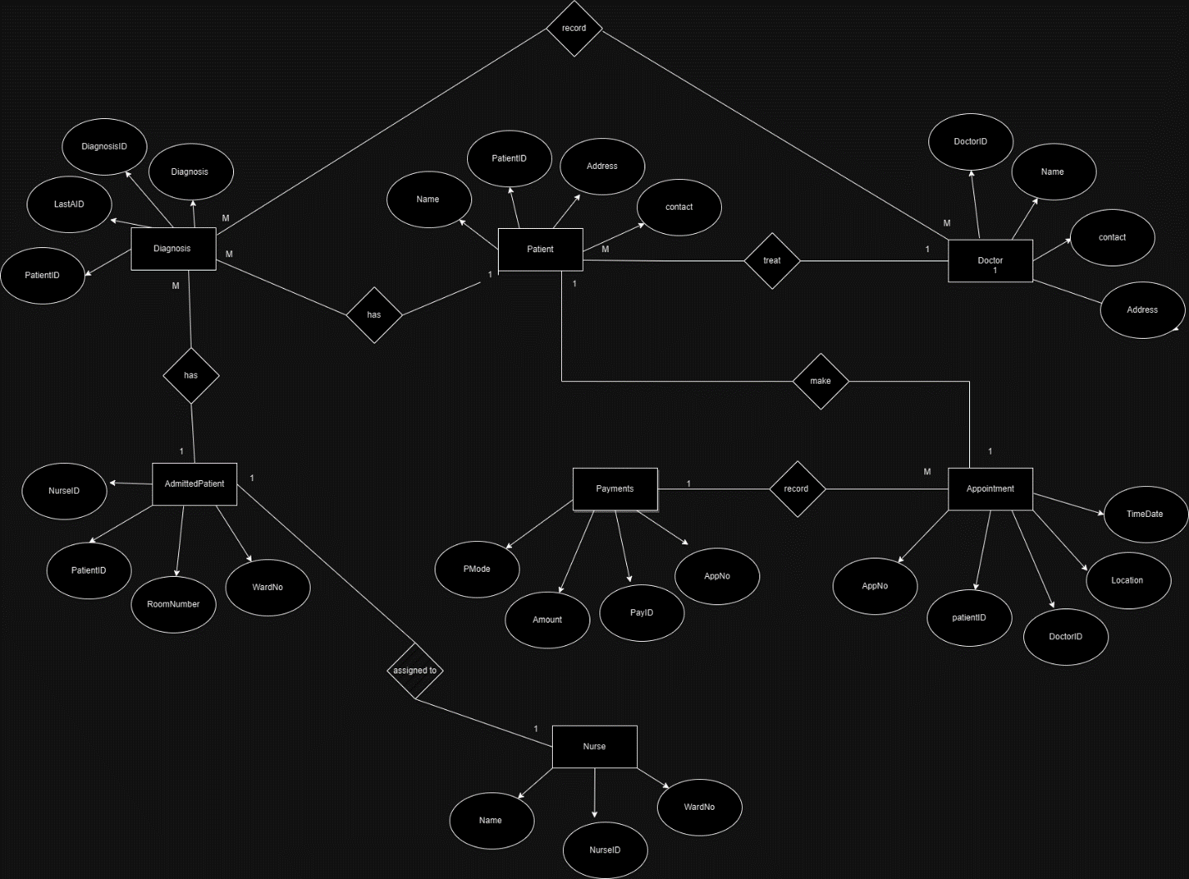

**Lab Sheet 07**